Chapter 6 Classification
extra worksheet 1: Using a circular key
Science understanding Visual/Spatial
Name: Class: Date:
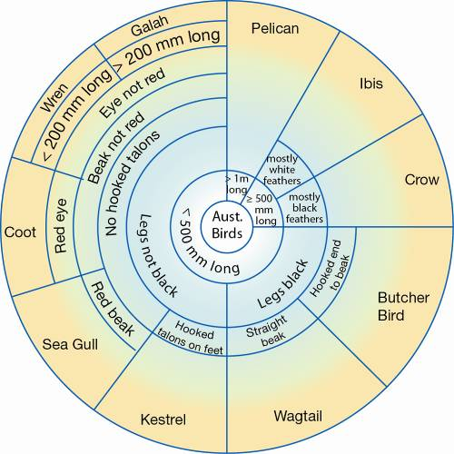
Occasionally keys used to identify organisms are arranged a little differently from chart keys or table keys. The key below is a circular key for Australian birds. Start from the centre of the circle and work out making a choice at each stage.
The first choice has three options: Greater than one metre long; greater than or equal to 500 millimetres long; and less than 500 millimetres long. The remaining choices have only two choices, as in a normal dichotomous key.
Example:
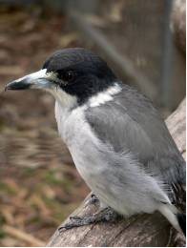 | This bird is 280–320 mm in length. It has a distinctive black head with a white collar. The eyes are dark brown, the bill blue-grey with a hooked tip, and the legs are black.
To identify this bird, start in the middle. Its length is less than 500 mm.
The next choice is whether the legs are black or not. This bird has black legs.
The choice for birds with black legs is whether the beak is hooked or not. This bird has a hook on the end of the beak. It is a butcher bird.
1 Identify these birds.
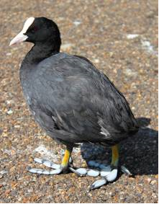 | a This bird is 320–390 mm long. Its feathers are black and it has a distinctive white frontal shield and beak. Its eyes are red. Its legs and feet are grey. The toes are lobed to help with walking over soft mud.
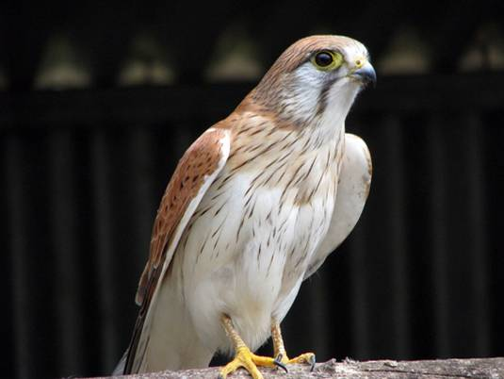 | b This bird is 310–350 mm long. The feathers on its back are a reddish colour. Its underparts and face are white. It has brown eyes, a blue-grey bill and yellow legs. Its toes have hooked talons that it uses to capture its prey.
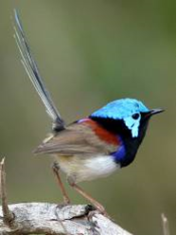 | c This little bird is only 140 mm long. It has a blue head, a chestnut patch on its back and a long tail that is a dull blue colour. It has brown eyes, a black beak and dark brown legs.

